
Dear Customer,
We are contacting you today because our records show that you are the current owner of the above Motorhome, and we need to alert you of the importance of adhering to our safety advice on the safe operation of your Sky View window installed in your motorhome, this is the large opening panoramic window situated above the driver and passenger seats in the Fiat cab.
This window is not designed to be used unsecured / open when the motorhome is being driven under any circumstances.
This has been advised in the user handbook and also using advice labels on the cab windscreen. Example of the advice label is provided below.
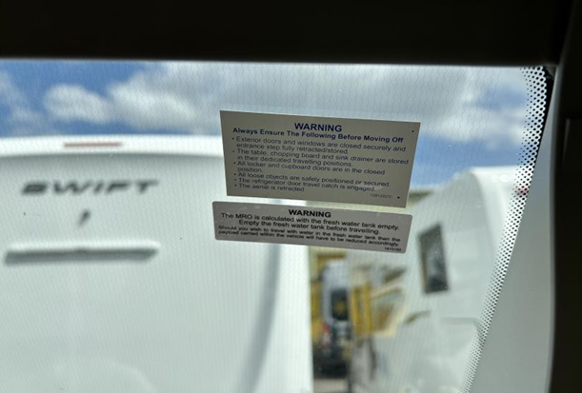
We have recently investigated several instances of failures relating to this window assembly and extensive testing undertaken by the supplier of the window system and independent test experts have determined that the cause of failure is that customers have accidentally, or otherwise, driven the vehicle with the window in an unsecured position and this has placed additional stresses on the window and its fixings.
An unsecured position is defined as being either:
- The window ‘open’ in an elevated position such that the window pane does not touch the internal seal, with the catches not securing the window in place
- The window ‘closed’ in a non-elevated position such that the window pane does touch the internal seal, with the catches not securing the window in place
Windows that are not safely fixed may detach while driving and cause accidents and injuries/damages to other motorists or innocent bystanders. Therefore, please ensure that the window is always fully closed and secured while driving.
For immediate peace of mind, a simple visual check can be undertaken to ensure that all the fixings are present and secure by following the simple steps below:
- Unsecure the window catches
- Open the window to the maximum position the mechanism will permit
- Inspect the six screws are present on the lower window hinge profile and that they appear to be fully secured in place i.e. the base of the screw head is flat on the profile and no screw thread is visible under the head.

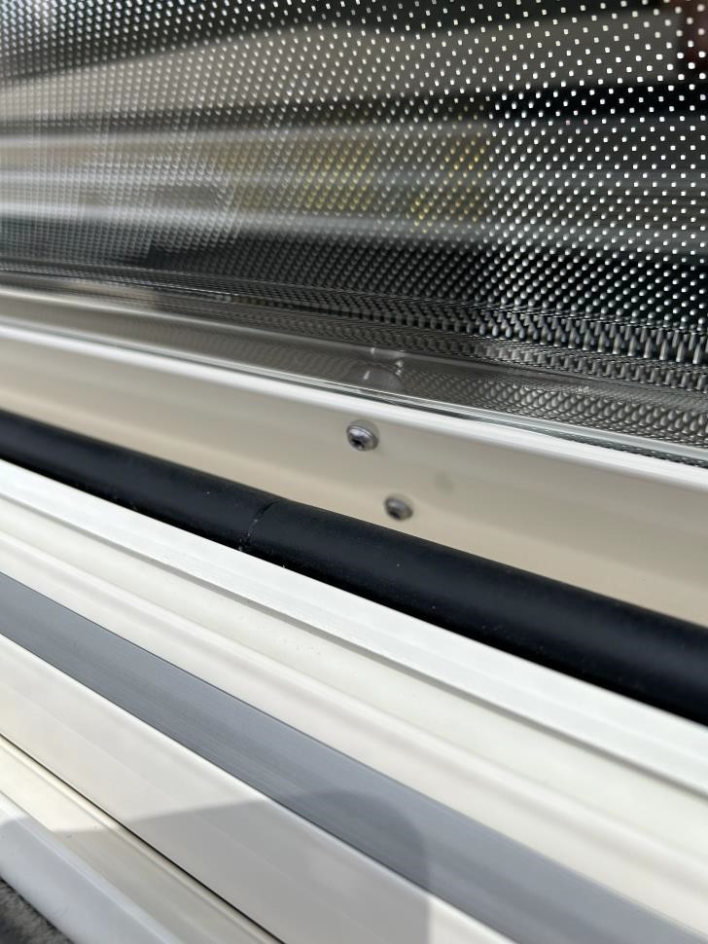
Figure 2 - Example of unsecured lower screw fixing with a loosened (lower) screw

If upon inspection, screws are missing or in an unsecured state then please contact a Swift Approved workshop or any AWS approved workshop that can rectify this issue quickly with a Fixing Kit supplied free of charge by the window supplier, however please note that dealers may charge for fitting.
Important, if you believe that you may have driven with the window in an unsecured position at any point during your ownership period, then we strongly advise you to have the window inspected and rectify where necessary by a Swift Approved workshop or any AWS approved workshop. Second or subsequent owners of vehicles shall also need to have this check undertaken to ensure that previous owners had adhered to the guidance on usage.
We have reported this window failure issue to the DVSA, and subsequently shared test procedures and results and we can confirm that the DVSA has now reviewed and closed their investigation.
If you are no longer the owner of this vehicle, I would kindly ask that you fill in the notification of change of ownership and return this in the envelope provided to allow us to contact the new owner as soon as possible.
If you have any questions or need further assistance, please email enquiries@swiftleisure.co.uk or get in touch via our website www.swiftgroup.co.uk
Are you a member of our Swift Owners Portal “My Swift Life”. If not, please register at www.myswiftlife.co.uk where you can find useful features and information. Come and join us today, we look forward to welcoming you.

